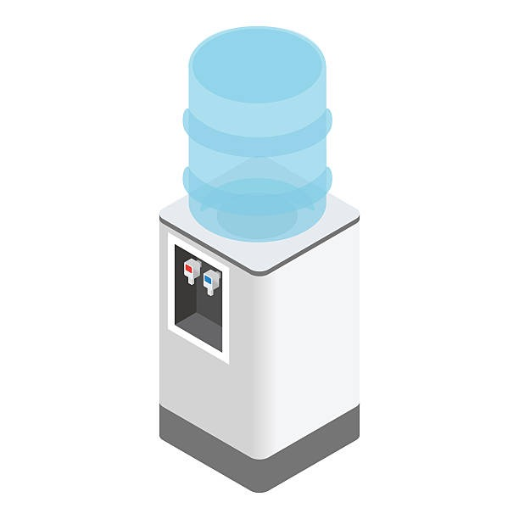
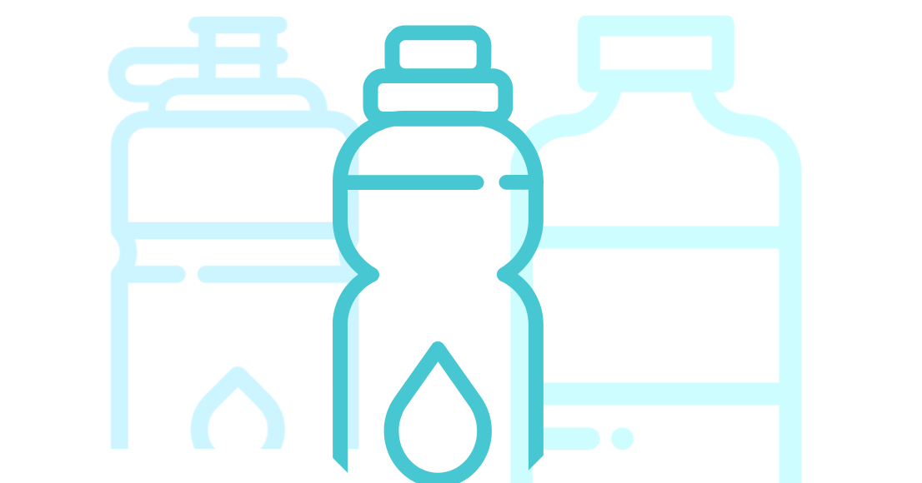
DITCH PLASTIC. USE THE COOLER.

US Demand for bottled water uses
17 million barrels of oil
which would be enough to fuel
1,300,000 cars a year
AVOID WASTE. BRING YOUR OWN BOTTLE.


#PLASTICFREE PRODUCTION

AVOID WASTE. BRING YOUR OWN BOTTLE.

#PLASTICFREE PRODUCTION

DITCH PLASTIC. USE THE COOLER.

BYOWaterBottle!

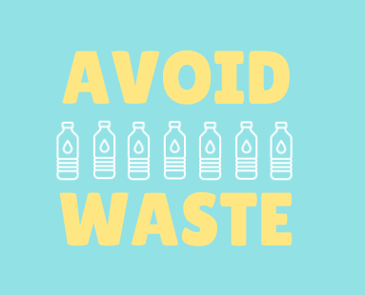
U.S. Demand for bottled water uses
17 million barrels of oil
which would be enough to fuel
1,300,000 cars a year
DITCH PLASTIC. USE THE COOLER.

