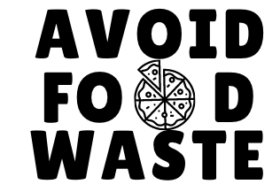

The average person in the U.S. wastes 20 lbs. of food per month! Only take what you need from catering.
[SHOW] donates any untouched food to local non-profit organizations. Help us reduce waste and our environmental footprint and….
ONLY TAKE WHAT YOU NEED
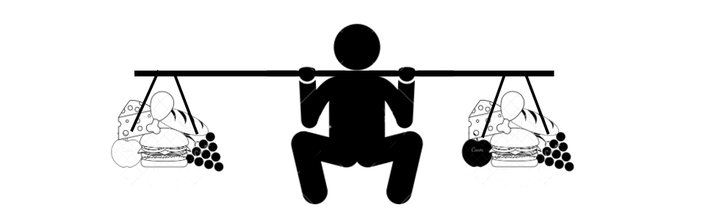
If the U.S. wasted just…
5% LESS FOOD
it would be enough to feed
4 MILLION AMERICANS
ONLY TAKE WHAT YOU NEED
DID YOU KNOW?
wastes 20 lbs. of food per month!
The average person

