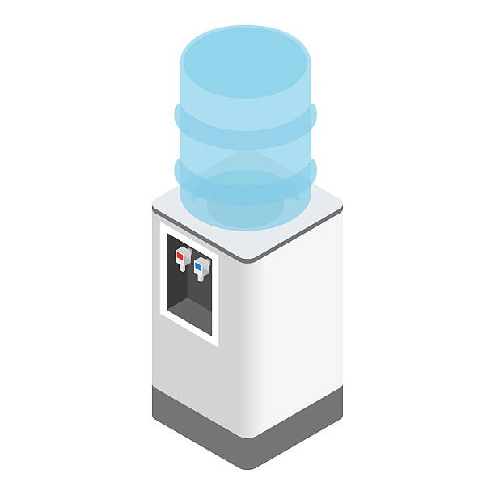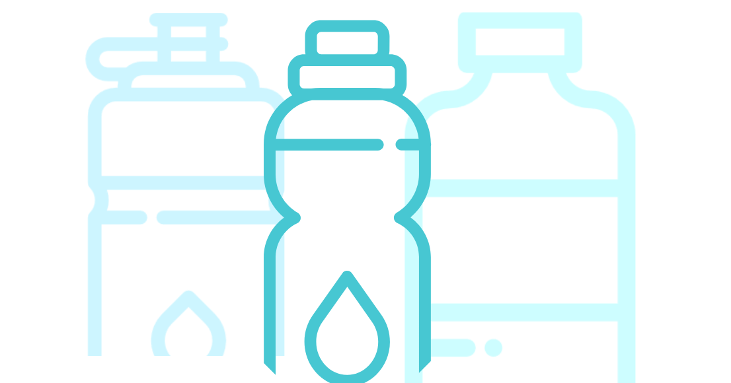

**DITCH PLASTIC. USE THE COOLER.**

US Demand for bottled water uses

**17 million barrels of oil**

which would be enough to fuel

**1,300,000 cars a year**

**AVOID WASTE. BRING YOUR OWN BOTTLE.**





**#PLASTICFREE PRODUCTION**

**AVOID WASTE. BRING YOUR OWN BOTTLE.**

**#PLASTICFREE PRODUCTION**

**DITCH PLASTIC. USE THE COOLER.**

**BYOWaterBottle!**

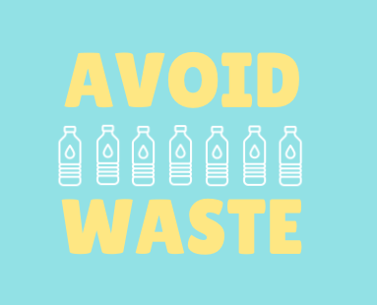

U.S. Demand for bottled water uses

**17 million barrels of oil**

which would be enough to fuel

**1,300,000 cars a year**

**DITCH PLASTIC. USE THE COOLER.**